Epsom & Ewell F.C.
15
v
Farnham Town
Saturday, 17th January 2015
For our League match this afternoon we welcome the players and officials of Farnham Town, along with today's match officials and of course our own regular supporters.

Our opponents come to us in a good run of form, most notably with a 6-2 away win over Cove. Whilst I thought we were unlucky at Oak Farm ourselves, a win of that size is quite an achievement, although they had a blip at home to Badshot Lea last Saturday who won 7-0!

We last met today’s opponents on the opening day of the season when we edged the points with two second half goals. I felt at the time that it would be a long hard season for them unless they could get better striking options and they have gone and done just that, giving them every chance of a top half finish right now.

For our part, we have recently been involved in some matches against teams right at the top, all while hampered by a number of suspensions. The last time we were here Windsor defeated us by five clear goals and although four of those came in the last quarter of an hour, you couldn’t argue that the visitors were pretty much on top throughout. This was not entirely surprising as we had to deal with another early red card and the ten men just ran out of steam at the end.

We then travelled to Ashford Town, where there was another early sending off, but this time it was for the opposition and we took full advantage, winning 3-1 against a team that would have gone top with a win and who won at Leatherhead in midweek. This was a tremendous achievement but we were denied the chance to back it up on Tuesday when our Surrey Senior Cup tie at Molesey was postponed. We now go there on Tuesday evening.

We then have a bit of time off coming up with no game next Saturday due to there being 21 teams in our Division, so our next match will be here in a fortnight when Westfield visit us.

From a fund raising point of view we are still looking for match and player sponsors. Currently we have managed to attract a sponsor for every home game, although our cover on the players is still patchy. Also, please support our Salts Super Six Prediction competition which now has a jackpot of £157. All you have to do is guess the results of six matches correctly and we have already had three people who got five of them right, so it won’t be long before someone is celebrating a reasonably large win!

Good luck to Colliers Wood in their F.A.Vase tie today, the full draw is included in this issue.

Rich

Cover photo this week by Gemma Jarman

The players line up in our new kit against Molesey recently,
which has been generously provided by Intercem.

Cherry Red Records
Combined Counties League
Premier Division Table 2014/15
inc Tuesday 13th January 2015 | P | W | D | L | F | A | Pts | GD | H | A
Cove | 24 | 17 | 4 | 3 | 58 | 37 | 55 | +21 | 7/3 | 0-1
Camberley Town | 23 | 17 | 3 | 3 | 57 | 16 | 54 | +41 | 7/2 | 0-1
Ashford Town (Mx) | 24 | 17 | 2 | 5 | 59 | 27 | 53 | +32 | 2-4 | 3-1
Molesey | 22 | 17 | 0 | 5 | 65 | 19 | 51 | +46 | 1-3 | 28/2
Windsor | 24 | 16 | 3 | 5 | 61 | 27 | 51 | +34 | 0-5 | 11/4
Hartley Wintney | 24 | 12 | 3 | 9 | 32 | 39 | 39 | -7 | 21/2 | 1-2
Spelthorne Sports | 22 | 12 | 2 | 8 | 47 | 39 | 38 | +8 | 4-3 | 3-0
Badshot Lea | 24 | 10 | 4 | 10 | 50 | 44 | 34 | +6 | 21/3 | 2-4
Colliers Wood United | 24 | 10 | 2 | 12 | 45 | 43 | 32 | +2 | 4/4 | 2-3
Epsom & Ewell | 24 | 10 | 2 | 12 | 44 | 43 | 32 | +1 | - | -
Mole Valley SCR | 24 | 9 | 5 | 10 | 46 | 54 | 32 | -8 | 1-0 | 5-2
Bedfont Sports | 23 | 9 | 3 | 11 | 32 | 42 | 30 | -10 | 0-1 | 2-0
Farnham Town | 23 | 8 | 5 | 10 | 47 | 55 | 29 | -8 | 17/1 | 2-0
Chertsey Town | 24 | 8 | 3 | 13 | 36 | 52 | 27 | -16 | 1-2 | 14/3
Raynes Park Vale | 23 | 7 | 4 | 11 | 30 | 40 | 25 | -10 | 0-1 | 14/2
Knaphill | 22 | 7 | 4 | 11 | 28 | 52 | 25 | -24 | 18/4 | 4-1
Horley Town | 23 | 6 | 4 | 13 | 44 | 62 | 22 | -18 | 2-2 | 6/4
Westfield | 23 | 5 | 5 | 13 | 33 | 47 | 20 | -14 | 31/1 | 0-4
Frimley Green | 24 | 5 | 4 | 15 | 41 | 67 | 19 | -26 | 0-0 | 25/4
Guildford City | 23 | 5 | 2 | 16 | 38 | 67 | 17 | -29 | 4-1 | 28/3
Hanworth Villa | 22 | 3 | 4 | 15 | 26 | 47 | 13 | -21 | 3/3 | 5-2

Lucky Day? – 17th January
Played 12 - Won 5 Drawn 3 Lost 4 - F 23 A 21 - PPG 1.50 - Average
Club record against Farnham Town
Played 10 - Won 5 Drawn 2 Lost 3 - F 18 A 17 - PPG 1.70 - Above Average
Their last visit
Saturday 11th January 2014 - Won 3-2 - Combined Counties League

Glyn Mandeville
Good afternoon! We welcome Farnham Town today after a quiet week, having had the Molesey game called off due to the weather.

In our last game against Ashford Town I felt we were going to be up against it with no less than seven players missing from the squad. I am glad to hear that Matt Farrell’s little boy is ok after being taken to hospital, hence Matt’s absence from the game, so that win was for them.

I felt we played well against a good side but for once we got a bit of luck and it was Ashford with a man sent off for a change and not us..... But with great lads and great character we got what I felt we deserved.

The lads worked so hard so I take my hat off to them a great 3-1 win, get in there! It was also good to see Agi score his first for the club and another new partnership up front seeing Daryl Cooper-Smith play up top with Kyle Hough (2) both playing very well. A great team performance!

Also, we welcome Robbie Burns back to the club - another great addition to the team. Just hope Lyndon keeps his hands off from now on ;-)

Enjoy the game!

Manders

Anthony Panayi
Good afternoon!

It's been a while since last writing, and in that time we have had many ups and downs.

The noticeable event in recent weeks was the disciplinary record before the win at Ashford. Although it's cost us on too many occasions there won't be many teams to beat Spelthorne with 10 men and to hold off a strong Windsor team for 70 minutes so we have taken the positives out of those games.

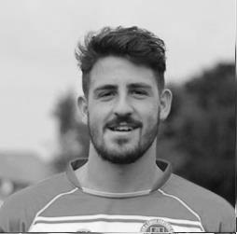
Ashford on Saturday showed exactly the positives we have taken and for the 11 first team players available it was up there with the game of the season. The team spirit and character from the group was clear for everyone to see.

Moving forward we know that our squad’s depth and quality is far stronger than the league table suggests and something we can't wait to start changing.

Massive thank yous for everyone who have continued to support us this season and we hope for another good result today!

COME ON YOU SALTS!

Ant

Results and Fixtures
Combined Counties League – Saturday 3rd January
Camberley Town | 3-1 | Knaphill
Chertsey Town | 3-1 | Guildford City
Colliers Wood United | 3-4 | Hartley Wintney
Epsom & Ewell | 0-5 | Windsor
Surrey Senior Cup Third Round – Wednesday 7th January
Dorking Wanderers | 3-4 | Colliers Wood United
Combined Counties League – Saturday 10th January
Ashford Town (Mx) | 1-3 | Epsom & Ewell
Farnham Town | 0-7 | Badshot Lea
Frimley Green | 1-3 | Colliers Wood United
Hanworth Villa | 0-2 | Camberley Town
Hartley Wintney | 3-2 | Horley Town
Knaphill | 1-1 | Chertsey Town
Molesey | 3-0 | Spelthorne Sports
Tooting & Mitcham United | 3-1 | Mole Valley SCR
Combined Counties League – Tuesday 13th January
Horley Town | 1-8 | Camberley Town
Surrey Senior Cup Third Round – Wednesday 14th January
Leatherhead | 2-3 | Ashford Town (Mx)
F.A. Vase Fourth Round – Saturday 17th January
Ascot United | V | Colliers Wood United
Combined Counties League – Saturday 17th January
Ashford Town (Mx) | V | Westfield
Bedfont Sports | V | Hanworth Villa
Cove | V | Badshot Lea
Epsom & Ewell | V | Farnham Town
Horley Town | V | Windsor
Mole Valley SCR | V | Chertsey Town
Molesey | V | Frimley Green
Raynes Park Vale | V | Hartley Wintney
Spelthorne Sports | V | Knaphill
Combined Counties League Cup Third Round – Tuesday 20th January
Farnham Town | V | Mole Valley SCR
Surrey Senior Cup Third Round – Tuesday 20th January
Molesey | V | Epsom & Ewell
Redhill | @ Westfield | Westfield
Results and Fixtures
Combined Counties League – Tuesday 20th January
Badshot Lea | V | Horley Town
Combined Counties League – Saturday 24th January
Badshot Lea | V | Ashford Town (Mx)
Camberley Town | V | Bedfont Sports
Chertsey Town | V | Spelthorne Sports
Guildford City | V | Molesey
Hanworth Villa | V | Knaphill
Hartley Wintney | V | Frimley Green
Horley Town | V | Cove
Raynes Park Vale | V | Mole Valley SCR
Westfield | V | Colliers Wood United
Windsor | V | Farnham Town
Combined Counties League – Tuesday 27th January
Cove | V | Frimley Green
Knaphill | V | Westfield
Molesey | V | Windsor
Combined Counties League – Wednesday 28th January
Colliers Wood United | V | Camberley Town
Combined Counties League – Saturday 31st January
Ashford Town (Mx) | V | Colliers Wood United
Bedfont Sports | V | Horley Town
Epsom & Ewell | V | Westfield
Farnham Town | V | Raynes Park Vale
Frimley Green | V | Hanworth Villa
Hartley Wintney | V | Guildford City
Knaphill | V | Badshot Lea
Mole Valley SCR | V | Camberley Town
Molesey | V | Cove
Spelthorne Sports | V | Windsor
Combined Counties League – Tuesday 3rd February
Badshot Lea | V | Hanworth Villa
Molesey | V | Chertsey Town
Mole Valley SCR | V | Farnham Town
Spelthorne Sports | V | Horley Town
Westfield | V | Bedfont Sports
Combined Counties League – Wednesday 28th January
Guildford City | V | Cove

From behind the goal
Badshot Lea 4-2 Epsom & Ewell
Combined Counties League - Saturday 13th December 2014

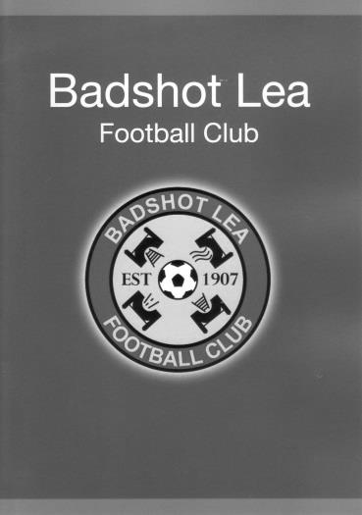
Ten man Salts run out of steam after brave battle

Epsom and Ewell visited Badshot Lea on Saturday and lost once again. Nothing unusual in that as our bogey team regularly beats us. What was frustrating about this one was that we went into the game in good form only to shoot ourselves in the foot by losing Sam Robinson to a red card in just the sixth minute. From that point onwards it was going to be an uphill battle. Robinson had come back into the line-up following his third suspension of the season at the expense of the absent George Murphy but otherwise it was an unchanged eleven that took the field for our first League battle in three weeks.

Maybe battle is too strong a word, as the players congregated for their “Football Remembers” pre-game picture, you were reminded of the sacrifices made one hundred years ago. However, on a boggy pitch that resembled a patch of no man’s land, both teams tried their best to recreate one of those famous confrontations in a fully committed, no holds barred contest.

The sending off followed a long ball from Robinson who was then caught late by a Badshot Lea player. He then got up and the resultant collision with their player was considered to be a head butt by the Assistant and it was game over for our midfielder. Moments later another heavy challenge earned their player a yellow card and it was clear that there was a stern physical challenge for our boys up ahead.

Now we like to play a bit of football when we can, but on this surface, real quality was going to be difficult to produce, especially in the centre of the park, so credit goes to our Management team for keeping our two wide men forward as this led directly to the opening goal of the game after 17 minutes. Matt Ferdinando made a great run at the home defence and tricked their defender into bringing him down just inside the penalty area. The referee wasn't sure at first but to his credit he once again relied upon his Assistant who was certain that it was a penalty. Kyle Hough put us ahead with ease to become just the third player in history to score his 150th goal for our club.

Hough got through again three minutes later but chose to shoot from a narrow angle and his effort required a good block from Aaron Watkins the home keeper. Ferdinando got another good shot in after 22 minutes which was well blocked by the keeper's feet before we had a slight scare at the other end when Anthony Panayi and Michael Eacott

had a breakdown in communication and we were nearly caught out but Panayi recovered the situation in the end. A couple of moments later it looked like Badshot would score an equaliser when a ball in from the right fizzed across our goal but luckily just in front of the incoming strikers.

Eacott made a good save a few minutes later but it was becoming apparent that the home side were beginning to get on top and were level in the 41st minute when a deep cross was met at the far post with a volley back across goal where Dan Simmonds was waiting to knock the equaliser in from close range. However, they had little time to celebrate before we had restored the lead when Ferdinando danced around in the area and was brought down yet again with Hough doing what he usually does from the spot in the 42nd minute.

Unfortunately there was time for the home side to score a second equaliser in first half injury time after Eacott had done well to parry a low shot but Jon Palmer was first to the loose ball for another tap in to kill the mood slightly as the teams went in for the half.

The general consensus at half time was that we would have to rely more and more on counter attacks as we would clearly tire on this heavy pitch. Ultimately that would turn out to be true but we started the second half well and should have gone ahead but Matt Robinson's low shot was somehow blocked just around the post by Watkins after 50 minutes. Then from a free kick for a foul Alex McGregor tried his luck from a narrow angle but Watkins was just there to prevent the ball creeping in, although from where we were you could see that it wasn't quite on target.

The hosts had their chances too. In the 59th minute they had a header just wide before a better opportunity came their way moments later when a clear chance was volleyed over. As they began to push us back Matt Farrell came on for McGregor in an attempt to protect our midfield but we were getting pushed back and James Taylor was booked for bringing down their flying left winger and from the free kick Eacott had to make another good low save. His and Epsom's luck ran out in the 73rd minute though when Badshot Lea worked a bit of space on the left and his cross in was turned in, initially it was felt by a Badshot player but the goal was credited as an own goal so it's hard to say what really happened there.

It looked as though our resistance was broken but in the final seconds substitute Ali Dewar sent in a great cross from the left wing and Hough rose like a throwback centre-forward to head the ball right into the top corner of the goal. It was the perfect finish. Except that the Assistant had his flag up and from the free kick twenty seconds later, Simmonds had scored his second and Badshot Lea's fourth goal to paint an unfair gloss on the score line. Sometimes the score really doesn't tell the full story.

Team: Michael Eacott, James Taylor, Matt Tanton Anthony Panayi ©, Alex McKay, Dan Dean, Matt Robinson, Sam Robinson, Kyle Hough, Alex McGregor, Matt Ferdinando

Subs: Matt Farrell for McGregor (63), Ali Dewar for Ferdinando (74), Sam Currie for Dean (84)

From the back of the stand
Epsom & Ewell 4-3 Spelthorne Sports
Combined Counties League - Tuesday 16th December 2014
Report by George Holland

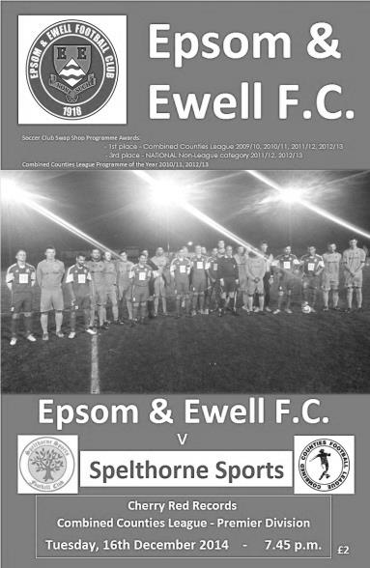
Seven Goal Thriller Spells A Win For The Salts

41 fans braved a cold night and saw thrills and spills galore as The Salts gained a much needed win and 3 points, and so doing the double over Sports. Even the Referee's Assessor said that the tempo went up in the second half, in a match full of defensive errors and attacking intent. I felt that our opponents had more mistakes in them, the longer the match went on, despite their lovely football!

The early play took a while to produce any real chances, before a shot on 27 minutes saw Michael Eacott pull off a superb save from a 25 yard shot that was not closed down. The resulting corner was cleared upfield. He then seized on a loose ball after he parried a shot on 31 minutes. James Taylor's header from a corner on 34 minutes sailed over the bar, as did Matt Robinson's header earlier. More chances were wasted before The Salts grabbed the lead in first minute of injury time when Alex McGregor's corner saw Alex McKay's header blocked by the visiting keeper, but Matt Farrell was first to the loose ball in a crowded area, to blast the ball home.

The 47th minute contained more joy for The Salts when a cross from Sam Robinson cause havoc in the visitors back line, and a defender headed beyond his keeper with Matt Robinson just reaching the ball before it went out of play to tap in from a couple of feet to double the lead.

Matt Ferdinando had a couple of efforts cleared, with Spelthorne responding with a header which Taylor headed off the line on 58 minutes. Unfortunately, McGregor was then sent off for his second bookable offence and almost

immediately the deficit was halved on 61 minutes. Epsom failed to clear a cross, and with the defence split, the ball came back off the far post and was knocked in by Simo Mbonkwi to ensure it was game on again.

The game now ebbed and flowed until 73 minutes when my Man Of The Match Ferdinando robbed his opponent, sprinted after it and from a narrow angle clipped a delightful shot into the far corner past the keeper's despairing dive. However, Spelthorne were not done yet and reduced the arrears on 75 minutes when a corner on the left was met by an unmarked header from Franky Law giving Eacott no chance for 3-2. As they say in footy, squeaky bum time!

Kyle Hough just failed to reach a ball when the visiting keeper spilt a shot, before they repeated their trick of scoring from a set piece after 81 minutes. A corner on the left was not gathered by Eacott, and the ball dropped to Lee Staples who shot home unmarked for 3-3. Time to chuck the tea cups around.

The visitors were now hunting blood, and we were up against it. Happily for the home supporters, on 87 minutes, we scored what proved to be the winner. In a mix up, a defender wrong-footed his keeper with a back pass. As the ball went across the face of goal it was clear that a defender would get there before Ferdinando, but as the man cleared the ball, our midfielder cleverly blocked the clearance into the net to the delight of the home fans, and most of the team who gathered round him to offer congratulations.

Going into 5 minutes of injury time, Spelthorne kept pressing, before Epsom countered. Substitute Ali Dewar skinned his marker down the left wing, fed Ferdinando, and with the defence nowhere, he was sure to get his hat trick, put it beyond doubt, and slam the ball home for 5-3. I was up out of my seat, but a defender's outstretched leg on the goal line cleared the danger. With the set piece being cleared upfield, the Salts ran out 4-3 winners. What a match to witness!

Team: Michael Eacott, James Taylor, Matt Tanton Anthony Panayi ©, Alex McKay, Matt Farrell, Matt Robinson, Sam Robinson, Kyle Hough, Alex McGregor, Matt Ferdinando

Subs: Ali Dewar for Hough (72)

Club Milestones
We have a few club milestones coming up very shortly.

Firstly, assuming he plays today, James Taylor will make his 50th appearance for the club the next time he takes the field. This will place him just three short of his father Dave, who played in 53 games during the 1985/86 season in the Isthmian League Premier Division. However, in that time he has scored three to Dave’s two goals and it looks like he will pass him soon on the appearance front.

Not many people are aware that he is currently at University down in Eastbourne yet has been travelling up for our matches over the last few months. That is a fair old trek home when you leave here at about 11pm after a midweek match! He made his debut on 26th August 2013 in our 2-0 win at home to Croydon and like his father he has been a regular since joining. I haven’t asked him but I would imagine that his goal to knock South Park out of the League Cup would be his highlight!

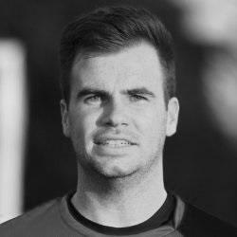
He is the 255th player to reach this mark in club history and the first since George Murphy on 6th September.

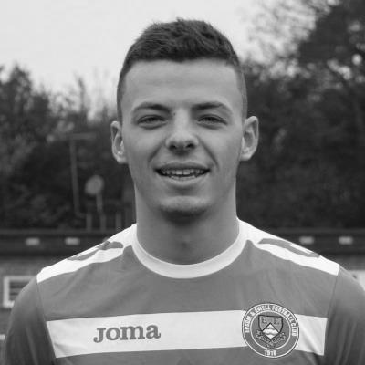
Alex McKay should make his 100th appearance for us at home to Westfield a fortnight today, becoming the 115th player to reach this mark and the first since Club Captain Sam Currie on 2nd August.

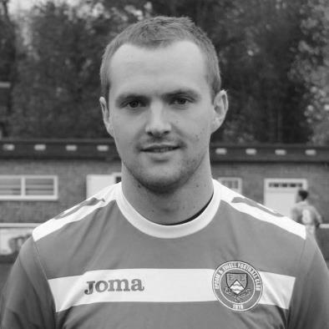
Alex has been with us for a bit longer than James since making his debut back in December 2008 when we were defeated 2-1 by a last minute Bedfont Green goal. He is very good at getting forward to score and has twice scored two goals in a game for us, firstly at home to Westfield in August 2013 and then more recently on 1st April 2014 when scoring an injury time winner with a thumping header against Windsor.

An even more significant milestone occurred at Badshot Lea on 13th December, when Kyle Hough became just the third player in our long history to reach the 150 mark for the club. This is a fantastic achievement with only legends Tommy Tuite and Reg Marlow sitting ahead of him.

Congratulations to all!

First Eleven Appearances - (max 31 inc Ashford)
Name | Debut | 2014/15 |  |  |  | Career Totals
 |  | App | Sub | Total | Goals | App | Sub | Total | Goals
BROWN Oshane* | 30/08/2014 | 2 | 0 | 2 | 0 | 2 | 0 | 2 | 0
COOPER-SMITH Daryl | 03/01/2015 | 2 | 0 | 2 | 0 | 2 | 0 | 2 | 0
CURRIE Sam | 04/08/2012 | 2 | 2 | 4 | 0 | 96 | 7 | 103 | 2
DEAN Dan | 02/08/2014 | 25 | 1 | 26 | 0 | 25 | 1 | 26 | 0
DEWAR Ali | 29/10/2011 | 5 | 4 | 9 | 3 | 55 | 33 | 88 | 10
DOUGLIN Karl* | 03/08/2013 | 1 | 0 | 1 | 1 | 41 | 3 | 44 | 14
DOWNS Carl* | 17/09/2011 | 4 | 1 | 5 | 0 | 94 | 13 | 107 | 2
EACOTT Michael | 02/08/2014 | 29 | 0 | 29 | 0 | 29 | 0 | 29 | 0
FARRELL Matt | 02/08/2014 | 27 | 2 | 29 | 3 | 27 | 2 | 29 | 3
FERDINANDO Matt | 20/09/2014 | 15 | 3 | 18 | 6 | 15 | 3 | 18 | 6
GAFFNEY Luke | 16/08/2014 | 10 | 1 | 11 | 0 | 10 | 1 | 11 | 0
HARPER Tommy* | 15/04/2014 | 1 | 0 | 1 | 0 | 2 | 1 | 3 | 0
HAYWARD Ben | 07/03/2007 | 6 | 0 | 6 | 0 | 242 | 28 | 270 | 18
HOADLEY Harry | 27/08/2011 | 6 | 1 | 7 | 0 | 7 | 1 | 8 | 0
HOUGH Kyle | 14/08/2007 | 27 | 1 | 28 | 16 | 281 | 13 | 294 | 153
JARMAN Mark | 08/08/2009 | 5 | 5 | 10 | 0 | 136 | 51 | 187 | 76
MARVELL Dale | 15/01/2000 | 11 | 5 | 16 | 5 | 261 | 45 | 306 | 85
MCGREGOR Alex | 08/08/2009 | 9 | 0 | 9 | 1 | 166 | 54 | 220 | 27
MCKAY Alex | 20/12/2008 | 6 | 4 | 10 | 0 | 71 | 26 | 97 | 7
MURPHY George | 28/03/2013 | 20 | 1 | 21 | 1 | 61 | 5 | 66 | 3
MUTIMA Lionel | 05/08/2014 | 4 | 2 | 6 | 0 | 4 | 2 | 6 | 0
NELMES Elliott* | 05/08/2014 | 2 | 0 | 2 | 0 | 2 | 0 | 2 | 0
PANAYI Anthony | 14/11/2010 | 23 | 1 | 24 | 0 | 150 | 15 | 165 | 4
PANAYIOUTOU Savva | 03/01/2015 | 2 | 0 | 2 | 1 | 2 | 0 | 2 | 1
ROBINSON Matt | 01/12/2012 | 13 | 1 | 14 | 1 | 14 | 4 | 18 | 2
ROBINSON Sam | 22/10/2011 | 18 | 1 | 19 | 6 | 42 | 4 | 46 | 11
ROWE Steve | 27/08/2011 | 5 | 0 | 5 | 0 | 10 | 1 | 11 | 0
SHAW Ollie | 20/09/2014 | 0 | 10 | 10 | 0 | 0 | 10 | 10 | 0
SMITH Matt | 08/08/2009 | 0 | 1 | 1 | 0 | 91 | 43 | 134 | 10
SMITH Taylor* | 02/08/2014 | 13 | 2 | 15 | 7 | 13 | 2 | 15 | 7
TANTON Matt | 02/08/2014 | 18 | 4 | 22 | 1 | 18 | 4 | 22 | 1
TAYLOR James | 26/08/2013 | 24 | 1 | 25 | 2 | 41 | 7 | 48 | 3
VAN GELDER Julian* | 12/09/2006 | 0 | 1 | 1 | 0 | 0 | 2 | 2 | 0
WHITE Sean* | 02/08/2014 | 6 | 13 | 19 | 3 | 6 | 13 | 19 | 3
Own Goal |  |  |  |  | 1
* Player has left the club

From behind the goal
Epsom & Ewell 0-5 Windsor
Combined Counties League - Saturday 3rd January 2015

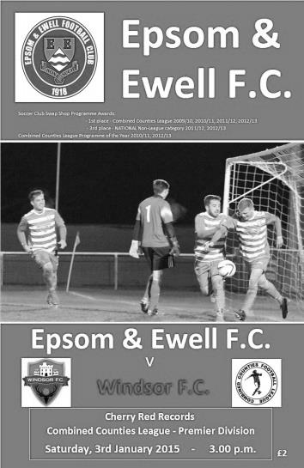
Threadbare Epsom unravelled by Windsor

An Epsom line up ravaged by suspensions suffered another early red card; our fourth in four matches, but battled heroically for 75 minutes before finally subsiding in the final fifteen minutes against a strong Windsor team in front of 116 spectators at High Road.

Alex McGregor, Matt Ferdinando and Sam Robinson, all midfielders, were kept off the field due to previous misdemeanours and Glyn Mandeville showcased two new players on the flanks as we operated with a 4-5-1 formation in an attempt to compete in the middle of the park against a team that are an excellent footballing side. Daryl Cooper-Smith and Savva Panayiotou, known as Agi, both showed promise, despite playing with ten men for 76 minutes and were worthy of another opportunity. Additionally, Ben Hayward returned for his first game in a few months.

Matt Tanton was also absent so Steve Rowe returned in his place as left back with George Murphy bravely turning out one again despite being in need of a hernia operation, while just in front of him Dan Dean rushed from Paris to be at the game. He will have regretted making the journey as his day only lasted for fourteen minutes, despatched for an early shower as a result of what was deemed a high and therefore dangerous challenge by the referee, so for the fourth game in a row we were down to ten men!

The visitors had started brightly before the sending off and Michael Eacott had already been in action as early as the third minute when saving from a free kick. He had a lucky escape in the sixth minute when he was given a weak back pass and his clearance was charged down by an incoming Windsor striker. Fortunately the ball lopped up into the air and Eacott made the easy catch. He would not be so fortunate later in the game.

We were threatening rarely in the early stages with only one real half chance falling to Matt Farrell who was at full stretch unable to direct Dan Dean's cross on goal moments before the sending off. After 21 minutes a header from the visitors

just looped over the bar and onto the frame of the goal before Hayward picked up a yellow card for a clumsy challenge and maybe was fortunate that he didn't make a proper contact with his opponent. A minute later Kyle Hough picked up a yellow card for retaliation after he had been held up by a crude block by the Windsor left back. Some of our players were saying that the defender was the last man, but as he was out so wide there was never going to be a red card, although how he escaped without punishment entirely was mystifying.

The visitors took the lead in the 30th minute. A ball fed in from the left was struck into our goal from around the edge of the penalty area by Rob Lazarczuk, giving Eacott no chance and we had a narrow escape just before half time when a Windsor volley bounced off our post and out for a goal kick.

We nearly conceded at the start of the second half when a back pass from Rowe was intercepted, but fortunately the striker was unable to do anything with the present. Apart from this the opening exchanges were more even. Windsor had another good chance when a low shot beat Eacott but was blocked on the line by the recently introduced substitute Alex McKay who then also managed to clear the danger.

Cooper-Smith linked well with Hough before getting a shot away although Dennison in the Windsor goal was able to deal with it easily. In the 63rd minute he had to work harder as Hough and a defender went up for a Farrell free kick; the loose ball dropping to Anthony Panayi who hit the ball well enough but just too close to the keeper who parried the powerful shot.

Regrettably that was as close as we would get, and we were dealt a tough blow in the 74th minute when a McKay back pass forced Eacott into another hurried clearance. This time George Gould blocked it and the ball rebounded into the net from fully eighteen yards for the second goal.

This was the straw that broke the camel's back. All our hard work to keep in the game was for nothing and the opposition seized on the opportunities to score a further three goals, with both Lazarczuk and Gould both scoring their second goals after 82 and 84 minutes and Travis Richardson-Hodge scoring a simple fifth after Eacott had produced a fine first save. This was an extremely harsh ending to the game for our boys as they battled against the odds today against a very good side and had the score stayed at 1-0 we could have claimed some sort of moral victory. It is to Windsor's credit that they denied us that; never looking to hold on to the single goal lead and always pushing for more.

Team: Michael Eacott, James Taylor, Steve Rowe, Anthony Panayi ©, George Murphy, Matt Farrell, Daryl Cooper-Smith, Dan Dean, Kyle Hough, Ben Hayward, Savva Panayiotou

Subs: Alex McKay for Murphy (51)

Matches in history against teams from Farnham
Our two teams have played each other in recent years but if you go back to an earlier time, teams from the town were big rivals and meetings between them were watched by thousands of interested spectators.

Now, it is not clear whether these two teams were linked, and the more I search, the more I believe they were separate, but it doesn’t matter.

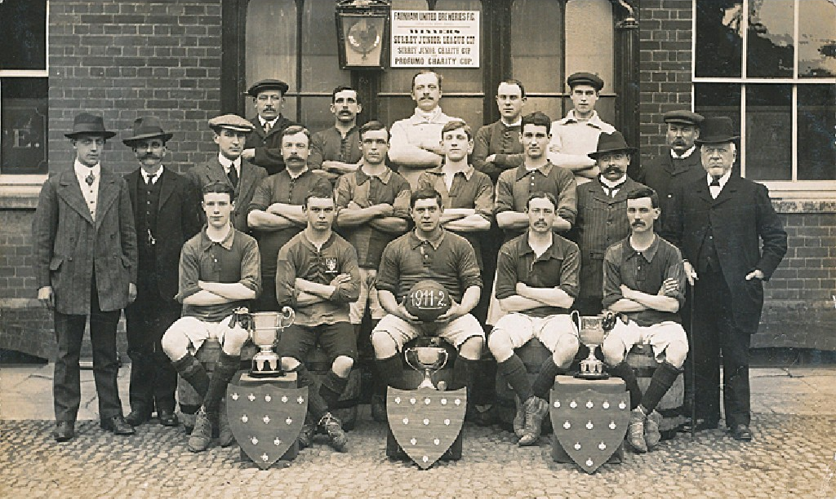
One thing I am sure about is that whilst Farnham Town were founded in 1906, Farnham United Breweries were in existence before then. The Brewery itself opened up in 1899, and whilst it is not clear when their works side started playing football, I have found a team picture for them from 1911/12. This appears to contradict an earlier assertion that the two clubs merged in 1906 unless the merger didn’t work and they went off on their own road again. These things happened all the time in the early days!

This team were very good and following the war they rose through the ranks at a rapid rate. They became Surrey Intermediate (West) division Champions ahead of Egham Town in 1920/21 and won the Surrey Intermediate Cup the same season. They then entered the Surrey Senior League on its creation in 1922/23 and although Egham won the first title, they won the League and Cup double in 1924.

In 1924 Epsom Town were unanimously accepted into the Surrey Senior League and battles between the two clubs commenced that Autumn. The first match was a memorable one, when we travelled down to West Surrey and handed the Cup and League holders a four-nil defeat in only our third competitive Senior status match. Reg Marlow scored twice on his debut as Epsom Town stated their intent to progress at this level. It must have been a shock for the more experienced side, but to be fair, they won the League again and defeated us 2-0 at Horton Hospital Grounds in April 1925.

The following season we secured a 1-1 draw with a late H.S. Streeter equaliser at Farnham in a match described by the local papers as “One of the finest exhibitions of football seen in the Surrey Senior League this season". There were many present, but there was a substantial crowd at West Street for the return match on F.A.Cup Final day, April 24th 1926 which was described as the biggest ever at West Street. There were many people unable to get in who were situated up the trees overlooking the ground and they were not to be disappointed as a goal in each half from our boys gave us a comfortable lead, although Bicknell pulled a goal back for the visitors and for the last twenty minutes “time crawled” before our win, and the League title were confirmed.

Farnham had also reached the First round of the F.A.Cup that season, losing 10-1 at home to Swindon Town, so it shows that we had a very strong team out ourselves in those days. Bicknell scoring their goal in the cup match. This is pure speculation, but I wonder if he was related to the two Bicknell brothers who played cricket for Surrey in the eighties and nineties, as they were both Guildford boys, the journey would not have been prohibitive.

Although I was unable to trace any more information about Bicknell, I have managed to trace a couple of very good players from their ranks. Leslie William Adlam was born on 24th June 1897 and appears to have moved into League football even before the club became one of the larger ones in Surrey, playing firstly for Guildford United, the forerunner of Guildford City, before making 279 appearances for Oldham Athletic. He played 56 times for QPR and four times for Cardiff in what appears to have been almost a tour of the country. Bizarrely he is then noted as playing for Guildford Post Office in the mid-thirties as his career wound down. He died in 1975.

However, the other player I traced would certainly have played against Epsom in the twenties. His name was Percy Charles Austin and he was born on 1st July 1903. He had great success as a centre forward before being signed by no less than Tottenham Hotspur. Their report on him is below:

One of the players to make only one appearance for Tottenham, Percy Austin had a short playing career, but served Spurs well off the field for several years. He played for Farnham United Breweries FC in the Surrey Senior League and was part of the side that reached the First Round of the FA Cup with some great giant-killing performances in 1925-26 before they lost at home to Swindon Town.

Percy was first signed on amateur forms and then, after some good displays in the reserves (nine goals in seventeen matches) he was signed as a professional at the end of that season. Unfortunately, his only first team match was as a replacement for the injured Arthur Grimsdell, who took a knock on Boxing Day 1927, giving him an opportunity to start against Birmingham City on 31st December that year. He didn’t score in a 2-3 loss at St Andrews.

He stayed for the rest of that season and was then allowed to join Norwich City in November 1928, after scoring 31 goals in 51 run-outs for Tottenham Reserves, but never made a senior appearance for the Canaries.

Percy returned to Hertfordshire and lived in Bricketts Wood, becoming the Spurs scout in the Hertfordshire area for many years. He died at St. Albans on 15th August 1961.

The 1926/27 season was to be our last in the Surrey Senior League as we would win the title and move up to the London League. What we probably didn’t realise at the time of meeting them was that this season would be their last as a football club.

We had a nightmare journey down to Farnham for the League match. Transport not being very good, the players were held up by a slow train and a charabanc that went the wrong way, requiring the club to hire three taxis from Guildford to cover the rest of the journey.

Then as soon as the game had started Reg Marlow damaged his ankle and was a passenger for the remainder of the game, while Harry Westlake made a jocular remark to a team mate that the referee took personally and was sent off, although we won the appeal against this decision.

Despite all this we were still the better side. We trailed to a couple of soft goals before fighting back after half time to equalise, only to then lose to a bit of a fluke goal when a cross dropped over everyone and into the net. It was one of only two league defeats that our club would suffer and we were to get our own back in spades later that season.

On 26th February 1927 the teams met at Ewell for the Semi-Final of the League Cup and we destroyed them 5-2, scoring twice in the opening five minutes, and they were never in it. Two weeks later we trounced them 6-3 in the return League match and that was that. The rivalry was over and at the end of the season we took the step up to the London League where we would remain for over twenty years..

In 1927 the Brewery were bought up by Courage Breweries and relocated to Alton in Hampshire and the team disappeared. It was a very sudden ending to a very successful club.

But where did they play? Well, my original thoughts were that they used the Memorial Ground currently inhabited by Farnham Town but I have not yet found any evidence to confirm this. The Breweries were in Red Lion Lane, just a large field and a small river away from the current ground, while there is an old off licence in West Street more or less across the road, so it could have been, while there are a cluster of newer houses across the road from Red Lion Lane that take up a similar shape and size to a football ground, so it could have been there too. However, if anyone from Farnham could advise further it would be appreciated.

One thing is clear though, not long after this time Farnham Town were quite successful at Intermediate level. Our first meeting with the current club took place on 21st April 1930 when our Reserves defeated Farnham Town 4-2 in the Final of the Surrey Intermediate Cup at Woking’s Kingfield ground with Farnham’s two goals coming from penalties. They were back again two seasons later, this time losing 5-1 to Carshalton Athletic’s second string and there was an Epsom v Farnham match of sorts in the 1935/36 season as West Park Hospital beat the Farnham Post Office in that season’s Surrey Intermediate Cup Final!

We did not meet again until October 1966, when the visitors, by now flying high in the Surrey Senior League like their predecessors, defeated us 3-2 in the Surrey Senior Cup, despite Epsom leading at half time. Goals from Benny Evans, who had started in goal as Terry Self was late arriving, and former Assistant Manager John Wood on his debut were not enough and Farnham went on to defeat Redhill and Carshalton Athletic in subsequent rounds.

By the time we met again in 1991/92 both clubs had dipped down and bounced back. We had dropped out of the Athenian League before charging up the Leagues again in the seventies

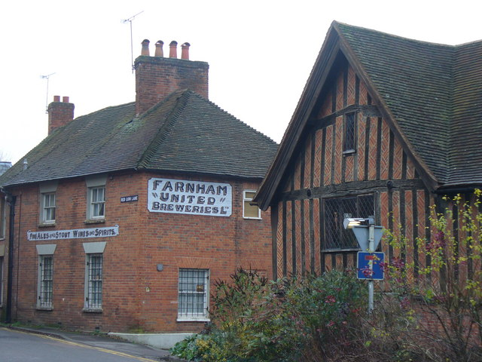
while Farnham had dropped into Intermediate football before returning. The Surrey Senior Cup tie provided Farnham with an ideal opportunity to see how far they had come. Back in the Combined Counties League, they were about to win the League by a decent distance, but froze against us that day. We won 3-1 but the main memory from this match was a stunning thirty-five yard strike from Simon Alldridge to put us on our way.

We were then due to meet in 1992/93 following their election to the Isthmian League but were unable to take their place and had to sit out the entire season.

Finally we met again for an unspectacular 0-0 draw and we now meet regularly again. However, way back then we might have had slightly bigger attendances!

Above: Red Lion Lane, Farnham, where the memory of the Brewery is still remembered, despite its closure nearly 90 years ago.

Below Left: Programme from the 1966 Surrey Senior Cup tie

Below Right: Programme from the 1992 Surrey Senior Cup tie

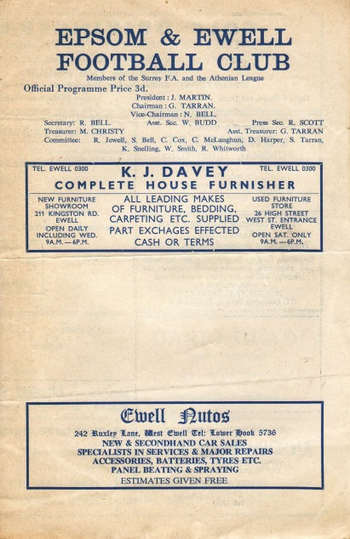
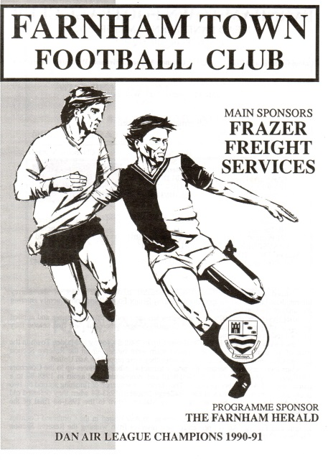

Club Records - 17th January
Date | Day | Competition |  | Opponents |  | Scorers
17/01/25 | Sat | Surrey Senior League | H | Leyland Motors | 3-1 | R.Marlow (3)
17/01/31 | Sat | London League | A | Grays Athletic | 4-3 | W.Challis, T.Jones, G.Prestoe, G.Mackesy
17/01/53 | Sat | Corinthian League | H | Grays Athletic | 1-3 | B.Goddard
17/01/59 | Sat | Corinthian League | A | Wembley | 0-0
17/01/70 | Sat | Athenian League 2 | H | Herne Bay | 0-1
17/01/76 | Sat | Athenian League 2 | H | Molesey | 2-1 | A.Reid, J.Eales
17/01/81 | Sat | Isthmian League 1 | A | Billericay Town | 2-2 | T.Tuite, L.Peck
17/01/84 | Tue | London Senior Cup 1 | A | Bromley | 1-2 | S.Milton
17/01/04 | Sat | Isthmian League 1 South | A | Met Police | 2-2 | o.g., C.Watkins
17/01/06 | Tue | Isthmian League 2 | H | Chertsey Town | 4-2 | C.Heuston, L.Purvis, C.Read, D.Marvell
17/01/09 | Sat | Combined Counties  Premier Division | H | North Greenford United | 3-2 | D.Marvell (3)
17/01/12 | Tue | Combined Counties  Premier Division | H | Raynes Park Vale | 1-2 | R.White
Historical Decades
90 years ago – Epsom Town
17/01/25 | Sat | Surrey Senior League | H | Leyland Motors | 3-1 | R.Marlow (3)
80 years ago – Epsom F.C.
19/01/35 | Sat | London League | A | Leavesden | 2-6 | W.Rich, H.Pullen
70 years ago – War time Epsom Town
13/01/45 | Sat | Friendly | H | London Fire Force | 3-4 | G.Brogdale (3)
60 years ago – Epsom F.C.
08/01/55 | Sat | Corinthian League | A | Maidenhead United | 2-2 | B.Brumwell (2)
50 years ago – Epsom & Ewell
16/01/65 | Sat | Athenian League 1 | H | Wembley | 2-1 | B.Mackay, o.g.
40 years ago – Epsom & Ewell
11/01/75 | Sat | Surrey Senior Cup 1 | A | Addlestone | 3-4 | T.Tuite, P.Walker, A.Webb
30 years ago – Epsom & Ewell
22/01/85 | Tue | London Senior Cup 1 | H | Hanwell Town | 3-0 | S.Hill (2), T.Tuite
20 years ago – Epsom & Ewell
21/01/95 | Sat | Isthmian League 3 | A | Camberley Town | 2-2 | S.Miller (2)
10 years ago – Epsom & Ewell
15/01/05 | Sat | Isthmian League 2 | H | Hertford Town | 1-3 | L.Purvis

History Corner – 17th January
90 years ago today we hosted Leyland Motors in a Surrey Senior League match at the Horton Hospital Grounds. The Motormen were based in Kingston and in the season to come (1925/26) would be the only team to beat us in League action, actually completing a double over us. However, this day it was Reg Marlow who did the necessary, as he often did, with a hat trick in our 3-1 win.

60 years ago this week we travelled to York Road for a League match with Maidenhead United and secured a 2-2 draw with two goals from Brian Brumwell. Football wasn’t the Essex lad’s best sport though, as he was also an excellent table tennis player who beat former 1949 and 1951 World Champion Johnny Leach in a tournament! Leach died last year at the age of 91 but Brumwell is still alive at the age of 87 and is President of the Ilford & District Table Tennis Association!

40 years ago this week we made the short visit to Addlestone for a Surrey Senior Cup tie. Addlestone were riding high in the Athenian League and remained unbeaten to this stage of the season but we were quite good ourselves, although we did trail 4-0 at one point. Three goals for the Blues led to a grandstand finish and although the Stones held on to win this game, six weeks later we were to meet at West Street in the F.A. Vase Quarter-Final where the positions would be reversed!

11 years ago today a young Craig Watkins announced himself on the footballing stage with a great strike at Imber Court. With Epsom approaching what would become a club record twenty-nine matches without a win, we trailed at Met Police who had not won in twelve themselves.

A Nick Williams shot was deflected in for an Epsom equaliser right on half time before Watkins smashed the ball into the top corner in the second half. Unfortunately a good chance was missed and the hosts equalised with five minutes remaining. Watkins went on to play for Sutton United and then on to Exeter City for a while and ironically is now banging them in for Met Police!

9 years ago today we took on local rivals Chertsey Town and despite them being near the top while we would end up in the bottom two, it was our day. Three long range strikes from Chad Heuston, Chris Read and Dale Marvell added to another from Lee Purvis shell shocked our visitors as we triumphed by four goals to two at Merland Rise.

The irony was that this was Manager Ray Purvis’ last game as Manager as he and Assistant Tony Webb were sacked a few days later for what was described off the record as some unethical practices by Webb, with Purvis linked by association. The official line was that results weren’t good enough and Paul Pritchard took over with Coach Peter Augustine remaining in his position.

6 years ago today Dale Marvell scored three times in the first half against North Greenford United at Merland Rise. Since then, we have had nine further hat tricks, yet all of them have been scored away from home!

Above and Below
Ryman League Division One South Table
inc Wednesday 14th January | P | W | D | L | F | A | Pts | GD
Burgess Hill Town | 25 | 20 | 5 | 0 | 64 | 20 | 65 | +44
Faversham Town | 29 | 20 | 5 | 4 | 75 | 37 | 65 | +38
Merstham | 29 | 17 | 9 | 3 | 73 | 34 | 60 | +39
Folkestone Invicta | 29 | 17 | 7 | 5 | 59 | 31 | 58 | +28
Worthing | 30 | 14 | 7 | 9 | 60 | 44 | 49 | +16
Whyteleafe | 29 | 12 | 10 | 7 | 55 | 38 | 46 | +17
Whitstable Town | 30 | 12 | 8 | 10 | 54 | 53 | 44 | +1
South Park | 25 | 11 | 6 | 8 | 51 | 47 | 39 | +4
Tooting & Mitcham United | 29 | 10 | 8 | 11 | 50 | 41 | 38 | +9
Chipstead | 28 | 10 | 8 | 10 | 44 | 48 | 38 | -4
Sittingbourne | 30 | 11 | 5 | 14 | 36 | 47 | 38 | -11
Carshalton Athletic | 30 | 10 | 7 | 13 | 40 | 42 | 37 | -2
Guernsey | 29 | 11 | 4 | 14 | 60 | 70 | 37 | -10
Herne Bay | 29 | 11 | 4 | 14 | 42 | 54 | 37 | -12
Three Bridges | 28 | 10 | 5 | 13 | 47 | 64 | 35 | -17
Walton & Hersham | 27 | 10 | 4 | 13 | 31 | 41 | 34 | -10
Corinthian Casuals | 27 | 10 | 4 | 13 | 39 | 51 | 34 | -12
East Grinstead Town | 29 | 10 | 3 | 16 | 39 | 59 | 33 | -20
Hastings United | 29 | 8 | 7 | 14 | 41 | 45 | 31 | -4
Hythe Town | 29 | 7 | 9 | 13 | 48 | 48 | 30 | 0
Walton Casuals | 28 | 8 | 4 | 16 | 39 | 58 | 28 | -19
Ramsgate | 27 | 7 | 4 | 16 | 31 | 57 | 25 | -26
Redhill | 25 | 6 | 4 | 15 | 39 | 59 | 22 | -20
Horsham | 26 | 5 | 5 | 16 | 27 | 56 | 20 | -29
This is developing into an incredible season for Burgess Hill Town. A club that faced financial difficulties a season or two ago have clearly sorted those problems out and they remain unbeaten and likely Champions of the Ryman League South Division.

The field has become a bit stretched out behind them, although Faversham, Merstham and Folkestone have not lost sight entirely and all three seem destined for the play offs.

Right now the team looking most likely to join them are Worthing, although newcomers Whyteleafe and South Park could pass them by winning their games in hand. Both have adapted well to their new surroundings.

As you look down the table it is clear that the Guernsey experiment has foundered. Many thought they would be able to sustain a position in the Premier Division, if not higher, but this season even the playoffs look a bridge too far. This also appears the case for Carshalton Athletic, who have bounced straight back from previous relegations but it won’t happen this time.

East Grinstead Town appear to have put on a bit of a spurt, leaving other, larger names in their wake like Hastings United, Ramsgate and most surprisingly Horsham. It would be a disaster for a club with their recent successes to drop to Step Five, but that’s what losing your ground can do to you. If they get out of trouble it looks like Redhill plus two old perennials, Walton Casuals and the plummeting Corinthian Casuals that will battle it out for survival. Walton Casuals did their cause no harm by beating South Park 2-1 on Wednesday.

Above and Below
Combined Counties League Division One Table
inc Wednesday 14th January | P | W | D | L | F | A | Pts | GD
Farleigh Rovers | 20 | 13 | 3 | 4 | 41 | 28 | 42 | +13
AFC Croydon Athletic | 18 | 13 | 1 | 4 | 57 | 19 | 40 | +38
Worcester Park | 16 | 10 | 3 | 3 | 44 | 23 | 33 | +21
Bedfont & Feltham | 17 | 9 | 3 | 5 | 33 | 33 | 30 | 0
Ash United | 18 | 8 | 5 | 5 | 31 | 24 | 29 | +7
Banstead Athletic | 14 | 8 | 3 | 3 | 31 | 18 | 27 | +13
CB Hounslow United | 21 | 8 | 3 | 10 | 40 | 43 | 27 | -3
Eversley & California | 14 | 8 | 0 | 6 | 30 | 27 | 24 | +3
Staines Lammas | 16 | 6 | 4 | 6 | 34 | 28 | 22 | +6
Cobham | 14 | 6 | 0 | 8 | 31 | 21 | 18 | 10
Dorking | 16 | 5 | 2 | 9 | 26 | 37 | 17 | -11
Alton Town | 18 | 5 | 2 | 11 | 29 | 44 | 17 | -15
Sheerwater | 19 | 5 | 2 | 12 | 25 | 47 | 17 | -22
Epsom Athletic | 16 | 3 | 4 | 9 | 30 | 52 | 13 | -22
Sandhurst Town | 22 | 5 | 1 | 16 | 35 | 72 | 13 | -37
Chessington & Hook United | 9 | 3 | 2 | 4 | 20 | 21 | 11 | -1
The first thing I notice when looking at the League table is the number of games Chessington & Hook United have played! Traditionally they have had trouble but runs in Cup and Vase haven’t helped their case and with the rainy season ahead of us, it could get worse.

As a result of this it is difficult to work out whereabouts they should be sitting in the table, but one thing is clear in that Sandhurst Town and Epsom Athletic have a lot to do to avoid the wooden spoon this year. Of course we have recently picked up Robbie Burns from our local rivals which won’t help them, although relegation is not a fate that awaits either club.

Instead, three other clubs face expulsion from Step Six football, all because of the lack of floodlighting. Farleigh Rovers, Sheerwater and Worcester Park have been told by the F.A. having been originally threatened a few years back of this eventuality. Other clubs have got lights now and it does surprise me why Park are unable to get them, being situated in close proximity to a well lit train station, but what exactly will happen to the clubs next season remains to be seen.

There are other clubs applying for Step Six status, one of whom are the newly former Tooting & Mitcham Wanderers, who share at Whyteleafe, while Abbey Rangers and Balham have also applied, but I am unaware of the facilities these Step Seven clubs have presently. Tooting & Mitcham Wanderers will get the grading but are not currently well placed enough for promotion, so we will have to see whether any of these clubs will join our League.

So who will come up and what does this mean for the clubs at the wrong end of our Division? Well, the good news for the Premier clubs is that three going down appears unlikely right now. Only clubs in the top three can come up, although there is always the possibility of a transfer in the shape of say, Dorking Wanderers, while AFC Croydon Athletic will surely return now that they are back at Mayfield Avenue. Farleigh look likely to keep one of the top three places, ensuring frustration for the casing pack while Worcester Park’s greatest challenge comes from Banstead Athletic it appears.

F.A. regulations say one club must drop and it could well turn out that we might be sending Frimley Green down in our final fixture as I think Hanworth Villa and Guildford will finish higher.

Centre page for results

Centre page for results

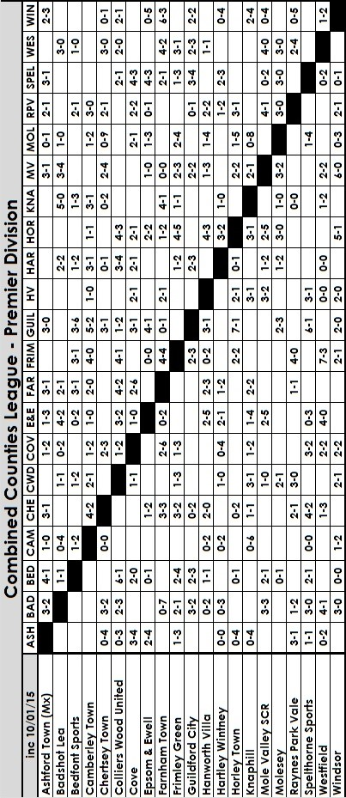

EL Records Premier Challenge Cup
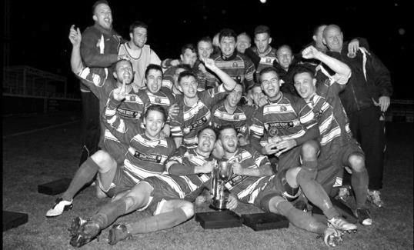
Second Round
Alton Town | 1-4 | Farnham Town
Ashford Town (Mx) | 5-0 | CB Hounslow United
Badshot Lea | 10-2 | Dorking
Bedfont Sports | 1-1+ | Cove
Cove won 4-1 on penalties
Camberley Town | 0-0+ | Molesey
Camberley Town won 3-0 on penalties
Chertsey Town | 0-7 | Windsor
Cobham | w/o Horley | Horley Town
Colliers Wood United | 3-0 | Bedfont & Feltham
Epsom & Ewell | 2-1 | Knaphill
Epsom Athletic | 0-5 | Banstead Athletic
Eversley & California | 2-4 | Ash United
Frimley Green | 1-0+ | Spelthorne Sports
Hanworth Villa | 2-3 | Guildford City
Sheerwater | 1-6 | Mole Valley SCR
Westfield | 4-0 | Farleigh Rovers
Worcester Park | 1-0 | Chessington & Hook United
Third Round
Westfield | 20/1 | Cove
Badshot Lea | 5-0 | Guildford City
Worcester Park | 27/1 | Banstead Athletic
Farnham Town | 20/1 | Mole Valley SCR
Frimley Green | 0-5 | Epsom & Ewell
Windsor | 8-1 | Ash United
Colliers Wood United | 3-2 | Horley Town
Camberley Town | 3-0 | Ashford Town (Mx)
Quarter Finals
Colliers Wood United | V | Badshot Lea
Worcester Park / Banstead Athletic | V | Windsor
Epsom & Ewell | V | Camberley Town
Farnham Town / Mole Valley SCR | V | Westfield / Cove

Norman Dearlove 1936 - 2014
Our club will be holding a minute’s silence today to commemorate the passing of Norman Dearlove.

Some of you will not have heard of Norman, so as a tribute from the club, here is a little bit about him.

Norman Dearlove was a goal scoring legend in his day. Starting at Carshalton Athletic before moving to Banstead Athletic, Epsom FC, Sutton United and Redhill he hit the net on a frequent basis.

To give a description of Norman’s style of play, you probably have to go back a few years and the only realistic comparison I can think of in the last twenty years is Mark Hughes. He was a handful to mark and he gave as good as he got in a brutal era. He was known as “The Tank” because he was a stocky but not particularly tall player and would almost run over his opponents!

He also knew exactly where the net was, and for us he scored 29 goals in just 28 appearances and was also a member of the team that won the Corinthian League Memorial Shield in 1960 when we defeated Maidenhead United 2-0 at Vale Farm, Wembley F.C.

Norman was born on Monday 20th April 1936 and stayed local for most of his life. His first club was Carshalton Athletic, where he worked his way up through the ‘A’ team, the Reserve and up into the first team, although struggled to hold a regular place and when they re-signed their own local hero Gordon Cairns, Norman knew that it would be difficult to succeed there.

So he moved to Banstead Athletic and had to follow club legend Harry Clark, a striker that regularly scored multiple hat tricks for the Surrey Senior League heavyweights. Some days Norman would score five or six goals in a game only to be told by locals there that Harry would have got more!

He was approached by Bernard “Podge” Willis, who was playing for Epsom at the time and he came to us, making his debut on 9th January 1960, scoring on his debut as we won 3-2 at Meadowbank against Dorking F.C. In fact he would hit the net in nine of the first ten matches that he played, tallying twenty goals in those ten appearances!

These were great days at Epsom. The new Chairman John Martin had just bought the ground from the club and although that would cause us significant problems in the mid-seventies, Martin was a very keen and enthusiastic Chairman back then. A millionaire who had made his fortune during the war and was responsible for tinned Carnation milk amongst other things, he found a way to “entice” wholly Amateur players from one club to another. He would arrive for the games in his green Rolls Royce and I imagine would have been a very difficult person to say no to!

Stories of “boot money” are often related by players of this era and back in 1960 with a

maximum wage of £20 a week for the professionals, a white five pound note in the boot of the player after the game was quite a significant motivation for people who may have struggled to earn that all week in their regular jobs. Dearlove became one of the Chairman’s favourites and was earning £8 a week to start with, which quickly rose to £10.

We had a strong side that season as Norman joined the club alongside other experienced players like former Kingstonian player Peter Wood, former Sutton United player Jorgen Sorensen and Scottish Amateur International Ken MacDonald. Many of these players had joined mid-season, so by this time any hope of League success was gone but the Corinthian League Memorial Shield; the League Cup of its day was a target, and our striker found the net in the opening tie of the round; a 3-1 success at Erith & Belvedere’s Park View ground. We didn’t know it at the time but it would be the only time we would concede in the competition! The second round was a local derby at home to Leatherhead and both Wood and Dearlove scored twice in a 4-0 victory.

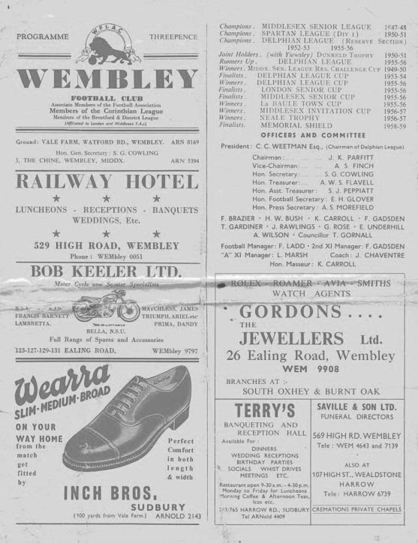
The Semi-Final was also easy as we blitzed Letchworth by five clear goals at West Street, again with Dearlove scoring twice which earned us a Cup Final match up with Maidenhead United, to be played at Vale Farm, home, then as now of Wembley F.C. Additionally it provided the chance of revenge for our team as we had been beaten 2-0 by the same opponents in the Cup Final three years previously. This time it was our turn and two second half goals by Steve Dunwoody, brother of long serving supporter Danny proved critical as we won 2-0 to lift the Shield.

Left: The match programme from our Memorial Shield win

This was the high water mark for Norman at our club and arguably his career, despite being only 25 at this time. In the Summer of 1960 he was offered some help by John Martin towards the deposit for a house, although this was put on hold due to an illness at the Estate Agents. In the meantime he accepted an invite to go on tour of Western Europe with Sutton United where the Chairman at the time Andrew Letts made him a similar offer and no doubt persuaded by many of the players he went on tour with, he chose to play for them in 1960/61.

One day when he was walking to a Sutton home game, Norman was approached by John Martin in Collingwood Recreation Ground. He offered to buy him the house he had just paid the deposit on and let him keep the remainder of a £500 cheque that he presented to him right that minute, just to come back and play for the newly named Epsom & Ewell FC!

Above: The Epsom FC team celebrate with the Memorial Shield on 30th April 1960
Back Row: Kennedy [Manager] Tony Wells, Bernard Willis. Ray Ellis,
Micky Williams, Tom Tweedy [physio], Tony Carroll, Steve Dunwoody
Front row: Bill Hawkins, Ron Francis, Peter Wood, Tommy Millard, Norman Dearlove

John Martin’s one mistake was that instead of closing the deal then and there, he said to Norman, quite understandably of course, to “have a think about it”. During that time Norman spoke to the Sutton United Captain Dave Leonard, briefly an Epsom player in the future. He originally suggested that Norman should go for it, but then clearly had a change of heart and spoke to some officials at Sutton United.

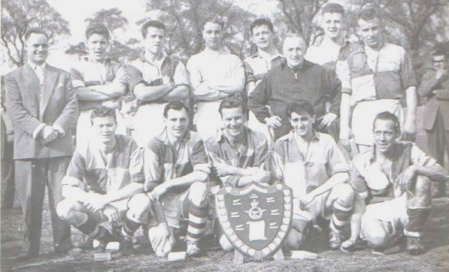
Then things got a bit nasty! After the game Letts, a Solicitor by trade, spoke to Norman having been advised of the situation. He said that this sort of thing was not Amateur and that if he took up the offer, Sutton would go to the F.A. and he would be “finished” in football. They took the cheque from him and later refused to return it. Norman also found out that his team mates would no longer pass him the ball.

He spoke to John Martin and explained that he wanted to come back to Epsom but really felt that he couldn’t do it under the circumstances and so went to Redhill before briefly returning to West Street in October 1961, although he soon moved on to Dorking, where a serious cruciate ligament injury forced him to take a break. In most cases back then, that would have been it but he managed to recover and was back with Epsom for the start of the 1964/65 season. Again though he didn’t remain long and after three more goals in seven appearances his time with us was over. A spell in Management with Redhill and then Dorking and Molesey, where he had success, but it is as a player that he will mostly be remembered.

I met him on a few occasions, most recently in January of 2013 when he came up to watch a home match at Chipstead. He was a real character and some of the stories of his on field combat made me wince at times! It is really tragic that after facing some really tough battles on the field, he was finally beaten by a chest infection, passing away on Tuesday 16th December at the age of 78. Rest in peace mate!

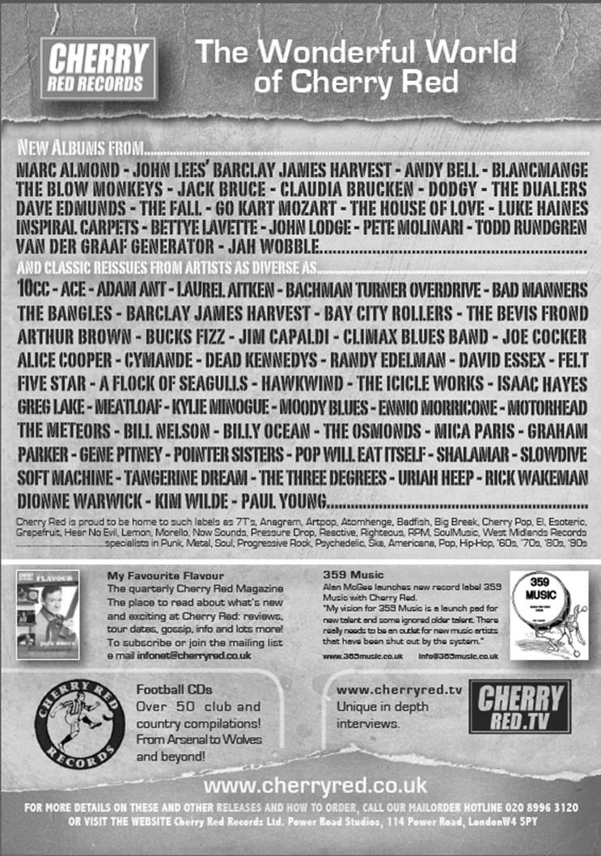

Player Sponsorship
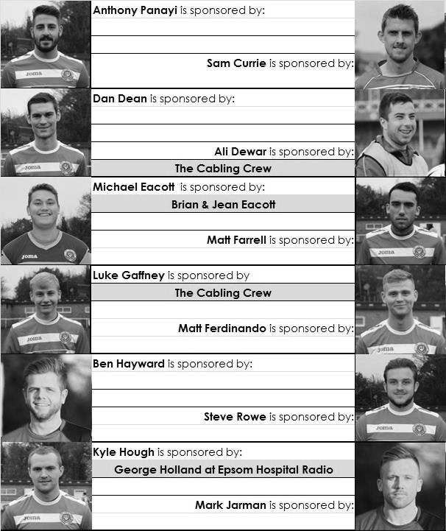

Here is the latest list showing all of the players and Management available for sponsorship. Sponsorship costs £40 so if you want to help the club, the player and get your name in the programme for the season, just let us know before they go!

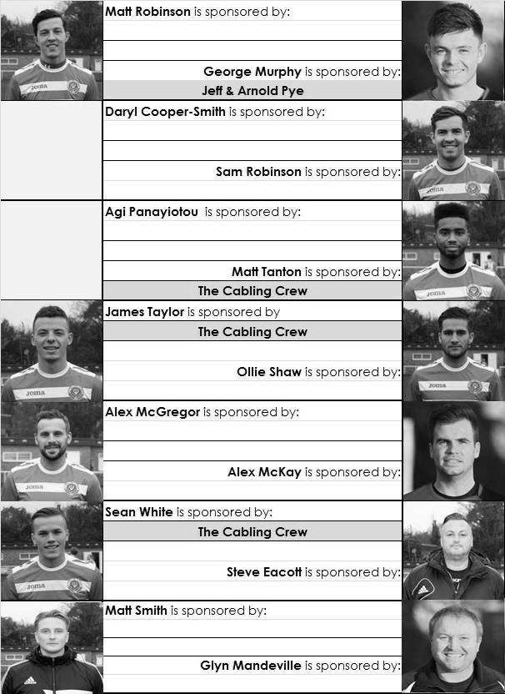

Every Opponent A-Z
Over the years we have played many, many different opponents. Exactly how many is a difficult question, as it all depends on your definition. Are Camberley & Yorktown different to Camberley Town, or are Epsom Town different to Epsom F.C. or Epsom & Ewell F.C.?

In my analysis I have classed them as the same team, and will work through them all from A to Z. Some we have played many times, whilst others we have met maybe just once or twice. Enjoy!

Merton Rushmere: Played 2 - W1 D1 L0 - F4 A2 - PPG - 2.00 - Very Good

Not to be confused with Merton F.C. that I covered in the previous instalment, this side were a Surrey Senior League team for a little while and we met in the Surrey Senior Cup, during season 1968/69, requiring a replay and extra time to progress 3-1 at West Street after being held to a 1-1 draw at the Wimbledon Park Stadium.

Merstham: Played 11 - W6 D1 L4 - F29 A20 - PPG - 1.73 - Very Good

Because of our two year groundsharing arrangement with our friends from Moatside Merstham appear a more familiar side to us than is actually the case, although there are just eleven meetings between us, spanning fifty years.

Our first meeting came in 1965 for a Surrey Senior Cup tie. The Merstham Manager was former Epsom striker Johnny Bangs and the pitch was at a 90 degree angle to where it is now. If you can picture the small stand at Merstham that is behind the far goal at Moatside, that used to be the midway point of the pitch!

We were a higher level back then and won 5-0 on the day, and our good record continued because our next meetings were in the Surrey Senior League during the mid-Seventies. Five straight wins followed; four in the League and one in the Charity Cup Semi-Final as we completely bossed them.

It therefore came as a massive shock when we then lost 4-5 at home to them in the F.A. Vase in November 1975. After having reached the Final the previous season, to lose at home to a club from a lower league was a major shock to our boys and Manager Pat O’Connell.

My first visit to Merstham was as a result of a pre-season friendly in the early nineties so it was a bit of a shock when we returned there in September 2006 for a League match and found the entrance in a different road and the pitch rotated by 90 degrees!

Of course that particular game was to be remembered for a far sadder reason as it was the first match played by the club following the sudden death of our long serving Secretary Dave Wilson three days previously. A minute’s silence was held impeccably by all who attended before we entertained high hopes of pinching our first win of the season when Phil N’gbale put us ahead. However, two goals in the final fifteen minutes, one by a player who would go on to play for us in Charlie West, ensured that the hosts took the points.

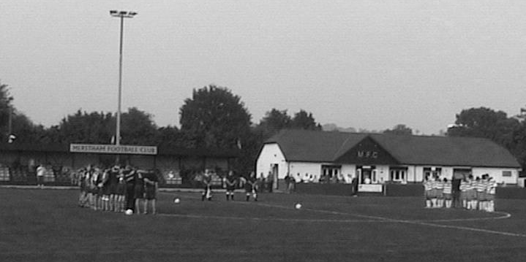
A picture taken during the minute’s silence at Merstham on Saturday 16th September 2006

By the time of the return fixture Merstham were in fine form and climbing the table and comfortably beat us 3-0 at Merland Rise. However, season 2007/08 was to be their big year as under Mick Sullivan and former Epsom player and Assistant Manager Micky Stratford they lost their opening match of the season at Cove but went the rest of the season unbeaten to win the League title. For good measure they also reached the Quarter–Final of the F.A. Vase, losing out to Needham Market, and won the Surrey Senior Cup for the first time in their history with a 3-2 win over Whyteleafe.

That season they battered us again at Merland Rise by four goals to one, before we secured a fine point from a 1-1 draw there in February 2008, thanks to a Kyle Hough rocket that flew inside keeper Ian Chatfield’s near post.

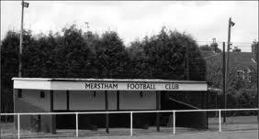
And that was that. Merstham were promoted to the Ryman League where they remain, and we have not met since, with exception of a couple of pre-season friendlies. However, we have reason to be very grateful to them for providing us with the offer of a ground share in 2010 and we were able to play there for two seasons before decamping to Chipstead.
Above: Merstham’s original stand which is now at the far end of the ground

From behind the goal
Ashford Town (Mx) 1-3 Epsom & Ewell
Combined Counties League - Saturday 10th January 2015

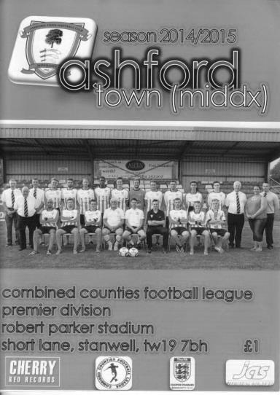
Salts sizzle in second half as another red card affects proceedings

Following last week's defeat to Windsor a match against Ashford Town was the last thing we needed; a match against a team in good form, chasing the title at a venue we hadn't won at since 2001!

We had Matt Robinson back from holiday and Alex McGregor back from his one game suspension, but Matt Ferdinando and Sam Robinson continued theirs while Dan Dean, Matt Tanton, Sam Currie, Ben Hayward and Matt Farrell were away. This left us with just two attending substitutes; our Manager and Assistant Manager! Additionally, George Murphy managed a full 90 minutes today, which was very brave for someone facing a double hernia operation shortly.

Under the circumstances this was a tremendous performance although the signs were not too promising at first, even after the tenth minute sending off of Jack Beadle for what appeared to be a kick at Matt Robinson. Whilst the incident was off the ball it was not witnessed by many but to his credit, the referee did spot it and sent the Ashford player on his way. Despite this the hosts kept much of their shape and had the majority of the chances. They failed to take any of them and as the half came to a close it was apparent that Michael Eacott hadn't actually had a shot to save. The best chance actually fell to Kyle Hough who was set up by good work from Savva Panayiotou and Matt Robinson but his chance from ten yards smashed up in the air off the crossbar and dropped down on the roof of the net.

This clearly gave our boys something to take from the first half performance as they had been second best to that point, even with a one man advantage. However, things were about to change and almost immediately from the second half we started to look more confident. With Panayiotou (known as Agi) and Robinson causing trouble down each flank, both had shots after cutting in onto their stronger feet as we started to work the home keeper Tyler Tobin more regularly.

In the 54th minute Tobin had no chance whatsoever as Alex McGregor won the ball in midfield and set up Robinson down the right. He cut back and found Hough who took a touch and buried the ball low into the net from a central position about eight yards out. After 57 minutes we headed a dangerous Ashford free kick away but the hosts were really struggling to create an opening and even their vociferous crowd, that had been baying at the referee in the first half in an attempt to get him to send our players off every time there was a foul, went quiet as they began to wonder if it wasn't their day.

A header from Daryl Cooper-Smith from a McGregor cross was blocked then gathered by Tobin before a routine shot at goal marked Eacott's first save of the day. We continued to work hard although the home side began to press and attacking substitutions were made, the second of which saw the introduction of former Salt James Cottee. Then in the 70th minute James Taylor was in an advanced role and flicked on a long Alex McKay throw on just beyond the reach of Hough and out for a goal kick.

It was looking like we might need a second goal to secure this win and a reminder of this came after 78 minutes when Eacott was at full stretch to palm away a decent volley and minutes later an overlap on the right nearly caused trouble but the ball in was easily claimed by Eacott. Fortunately a second goal was just around the corner and much credit goes to Cooper-Smith whose persistence in closing down a defender won him the ball. He set up Agi who dummied his defender and he smashed the ball past Tobin from close range in the 84th minute.

We were unable to hold onto what would have been a richly deserved clean sheet when a good through ball reached Kazi who had run beyond Taylor and he poked the ball beyond the advancing Eacott, but within seconds Hough latched on to a through ball and gave Tobin no chance again as our lead was restored.

This time we would hold on without further alarm although Matt Smith was required to make a substitute appearance right at the death in relief of McGregor. Overall though, this result made a mockery of our League position and whilst I'm sure it would have been a tougher job had Ashford had their full complement of players on the park, we've had our fair share of that recently ourselves and no one was sorry for us!

Team: Michael Eacott, James Taylor, Steve Rowe, Anthony Panayi ©, George Murphy, Alex McKay, Matt Robinson, Daryl Cooper-Smith, Kyle Hough, Alex McGregor, Savva Panayiotou

Subs: Matt Smith for McGregor (94)

Surrey Senior Cup
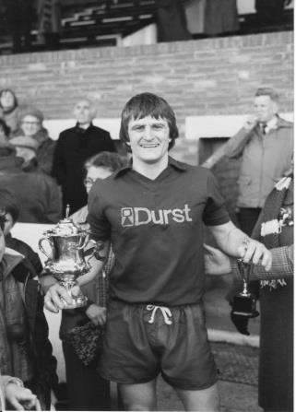
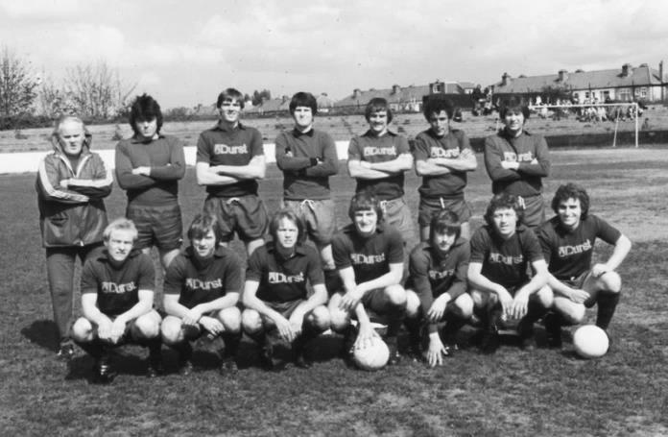
Second Round
Lingfield | 0-1 | Westfield
Redhill | 2-1 | Raynes Park Vale
Played at Raynes Park Vale
AFC Wimbledon | w/o Chipstead | Chipstead
Godalming Town | 2-4 | Mole Valley SCR
Knaphill | 0-3 | Colliers Wood United
Metropolitan Police | 1-0 | Walton & Hersham
Epsom & Ewell | 1-0 | Camberley Town
Leatherhead | 2-1 | Farnham Town
Merstham | 3-1 | Beckenham Town
Molesey | 1-0+ | Egham Town
South Park | 1-4 | Sutton United
Walton Casuals | 1-2 | Corinthian Casuals
Badshot Lea | 2-1 | Kingstonian
Dorking Wanderers | 9-0 | Frimley Green
Tooting & Mitcham United | 2-2+ | Horley Town
Tooting & Mitcham United won 4-2 on penalties
Woking | 0-3 | Ashford Town (Mx)
Third Round
Merstham | 2-1 | Sutton United
Redhill | 20/1 | Westfield
To be played at Westfield
Dorking Wanderers | 3-4 | Colliers Wood United
Molesey | 20/1 | Epsom & Ewell
Leatherhead | 2-3 | Ashford Town (Mx)
Metropolitan Police | 3-0 | Chipstead
Tooting & Mitcham United | 3-1 | Mole Valley SCR
Corinthian Casuals | v | Badshot Lea

F.A. Vase - Fourth Round – 17th January
Walsall Wood | V | Shaw Lane Aquaforce
Midland League - 12th |  | Northern Counties East Premier - 4th
North Shields | V | Consett
Northern League - 2nd |  | Northern League - 12th
Thurmby Nirvana | V | Holbeach United
United Counties League - 7th |  | United Counties League - 2nd
Chadderton | V | AFC Mansfield
North West Counties Division 1 - 14th |  | Northern Counties East Division 1 - 8th
Worksop Town | V | Glossop North End
Northern Counties East Premier - 2nd |  | North West Counties League - 2nd
Heanor Town | V | Dunston UTS
Northern Counties East Premier - 6th |  | Northern League - 4th
Tadcaster Albion | V | Brocton
Northern Counties East Premier - 1st |  | Midland League - 17th
Bodmin Town | V | Phoenix Sports
SW Peninsula League - 3rd |  | Southern Counties East League - 1st
Stanway Rovers | V | Saffron Walden Town
Eastern Counties League - 7th |  | Eastern Counties Division 1 - 1st
Ascot United | V | Colliers Wood United
Hellenic League - 6th |  | Combined Counties League - 9th
Bradford Town | V | Melksham Town
Western League - 8th |  | Western League - 2nd
Ashford United | V | Norwich United
Southern Counties East League - 5th |  | Eastern Counties League - 1st
Greenwich Borough | V | AFC St Austell
Southern Counties East League - 11th |  | SW Peninsula League - 4th
Flackwell Heath | V | Hullbridge Sports
Hellenic League - 4th |  | Essex Senior League - 10th
Highworth Town | V | Tunbridge Wells
Hellenic League - 9th |  | Southern Counties East League - 4th
Erith & Belvedere | V | Yaxley
Southern Counties East - 2nd |  | United Counties League - 3rd

Have you seen our new website?
For those who are unaware, our website, now over a year old, contains everything you could possibly want to know about the club and an enormous amount you may not have been aware of!

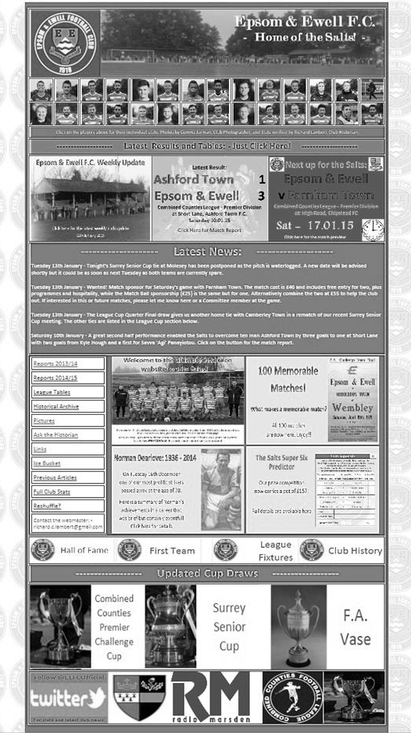
Our previous site still exists but as a photo archive only, housing the thousands of pictures provided by Gemma Jarman, our Club photographer. In addition, there are over a thousand historical images of teams, players, action shots and programme covers.

As you can tell from this screenshot of our front page, there is a substantial amount of information all available at the touch of a button, which is also very useful if you own one of those new touchscreen personal computers that are becoming more and more popular these days.

If you are a supporter, please pass the address on to anyone you know that has ever expressed an interest in the club, especially those who don’t visit any more. You never know, some of them might be inspired to come along too, and bring their friends, family etc.

http://www.eefconline.co.uk/

Today’s match – In memory of Chris Henry
On Tuesday July 13th 2004, the club lost one of its long-term supporters at the tragically young age of 46.

Chris Henry was well known to anyone that regularly attended Epsom matches in the past. He once told me that his first game was a 0-0 draw against Marlow at West Street on 25th January 1969, when he was only 11 years of age.

In those days, a 0-0 draw was looked on as a positive result, as the team was to go through some very dark days before its resurgence and subsequent Wembley appearance in 1975.

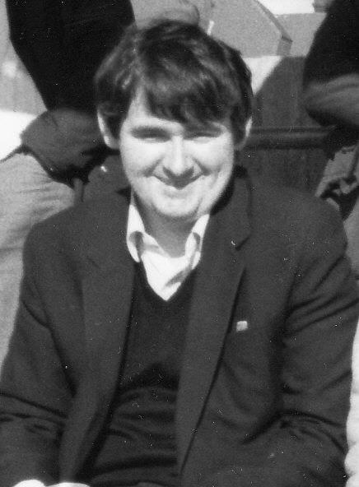
However, Chris stuck with it, supporting the club home and away throughout those bad times. Although there are older supporters who have seen the club play from an earlier date, there was no one else in my opinion that had seen as many games at the time as Chris had; only missing four or five a season on average at most during his long association with the club. He probably passed two thousand games if you include Reserve and Youth matches, of which he saw many.

I first met Chris in 1982. Both myself and John Steinmetz had started to attend some of the away games in our first season watching the club. Standing behind the goal at Wembley F.C. on 27th February 1982 we met up with Chris and Gary Vickers, and started to attend as many games as possible with them, usually taking a football with us. John, Gary and I would kick around in a nearby park, while Chris sat there watching and listening to his radio!

He may sometimes have come across to those who didn’t know him as a quiet individual, but once you could get him talking about music or football, he was a changed person and would be much happier. He is in a happier place now, and we all still miss him, particularly at times like today when the game is sponsored in his memory.

Our thoughts also go to his sister Mary and his brother Ray and family, all of whom have been regular visitors and match sponsors over the years.

Club Statistical History - (including Ashford Town match on 10/01/15):
League: Played: 2,779, Won: 1,131, Drawn: 527, Lost: 1,121
For: 5,091, Against: 4,960, GD: plus 131 - Win Ratio 40.7%

CCL only: Played: 358, Won: 157, Drawn: 69, Lost: 132
For: 625, Against: 573, GD: plus 52 - Win Ratio 43.9%

Cup and Other: Played: 1,082, Won: 518, Drawn: 127, Lost: 437
For: 2,357, Against: 2,015, GD: plus 342 - Win Ratio 47.9%

Abandoned Matches: Played: 8: For: 14, Against: 16

Under Glyn Mandeville: Played 21, Won: 11, Drawn: 0, Lost: 10
For: 41, Against: 39, GD: plus 2 - Win Ratio 52.4%

Total: Played 3,869, Won: 1,649, Drawn: 654, Lost: 1,558, Aban: 8
For: 7,462, Against: 6,991, GD: plus 471 - Win Ratio 42.6%

First Senior Match: 30th August 1924.
Lost 1-3 vs Dorking at our home ground at the time of Horton Hospital Grounds.

First Match Programme Issued: 15th September 1923.
Won 4-0 vs West Norwood Reserves - Friendly match at Horton Hospital Grounds.

Number of Official Home Grounds: Six.

Alexandra Recreation Ground 1918-1922,
Horton Hospital Grounds 1922-1925,
West Street 1925-1993,
Merland Rise 1993-2010,
Moatside 2010-2012,
High Road 2012- present.

Record Win: 12/10/1935. 13-1 v Reigate Priory (H) - Amateur Cup.

Record Defeat: 14/02/1948. 0-14 v Chelmsford City Reserves (A) - London League.

Longest Serving Manager: 1) Adrian Hill 853 1982-1985 & 1990-2003
2) Pat O’Connell 466 1973-1982
3) Lyndon Buckwell 407 2006-2014
4) Ricky Kidd 190 1986-1990

Record Appearances: 1) Graham Morris 658 1990-2004
2) Nigel Bennett 630 1989-2005
3) Tommy Tuite 582 1973-1987
4) Ernie Watkins 419 1945-1960

Record Goal Scorers: 1) Tommy Tuite 391 1973-1987
2) Reg Marlow 254 1924-1936
3) Jimmy Jones 148 1933-1945
4) Kyle Hough 137 2007-present

Most Appearances in a season: Tony Coombe and Tommy Tuite - 59 in 1980/81.

Most goals in a season: Reg Marlow - 65 (at least) in 39 appearances in 1926/27.

Senior League Titles: 5 - 1925/26 Surrey Senior League - 1926/27 Surrey Senior League - 1927/28 London League - 1974/75 Surrey Senior League - 1977/78 Isthmian League Division Two

Farnham Town – History
Established in 1906 through the merging of Farnham Bungs (the Farnham Brewery) and the Farnham Star. The club was one of the founder members of the London Spartan League in 1975. They reached the Fourth Round of the FA Vase in the 1976-77 season.

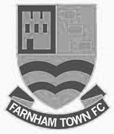
At the end of the 1979/80 season Farnham Town left the London Spartan League and applied to the Combined Counties League, their application was accepted and they finished 4th in their first season. The 1986/87 season saw Farnham take second place to Ash United in the league campaign. The glory days finally arrived in the 1990/91 season when the club won the league title. In the 1991/92 season, the Town got a clean sweep of the major trophies by winning the Combined Counties Premier League, the Dan Air Elite Cup and the Dan Air Challenge Cup. Having won the league, the club applied and were accepted to the Diadora (Isthmian) League, however funds for necessary ground improvements could not be generated which resulted in the club not having a league to play in for the 1992/93 season.

In 1993/94 Farnham Town were accepted back into the Combined Counties League where they continue to ply their trade. From 1995-1998 Farnham finished in the top six of the Premier Division for three consecutive seasons, in 1998-99 they finished in 13th position, then 10th in 1999-2000 before suffering relegation from the Premier Division in 2000-2001 season. They bounced straight back the following season but then endured four tough seasons back in the Premier Division, with bottom four finishes every season culminating in relegation back down to Division One in 2005-2006. Again, the club bounced straight back and in 2006-2007 they won the Division One title under the guidance of Barry Bridger, but were denied promotion due to the Memorial Ground not meeting the desired grading by the league. The club then spent another four seasons in Combined Counties Division One.

Farnham gained promotion from Combined Counties Division One in the 2010-2011season after finishing second behind Worcester Park. In Paul Tanner’s first season at the helm he gained automatic promotion back to the Premier Division at the first attempt, which after only retaining four members of the side from the previous year’s squad - who finished midtable, was quite an achievement. Paul Tanner’s side also won the Combined Counties Fair Play Award for 2010-2011 after going the whole season without having a man sent off, a record to be proud of.

In a very successful year for the club on the whole, Dean Nelson’s reserve side finished second behind Mole Valley in the Combined Counties Reserve Division, improving on fourth position the previous season. Farnham Ladies also finished second in their respective league to cap quite a remarkable season in Geoff Chapple’s final season as Chairman. In 2011, Ray Bridger took over as chairman from Geoff Chapple.

Current first team manager and now in his sixth season at the club is Paul Tanner, alongside head coach Sean Birchnall steered the club to 8th position in the 2012-13 season; the highest position for some 15 years. In 2013-2014 season Farnham finished in 13th place on 54 points.

Match and Ball Sponsorships – 2014/15
Opponent | Date | Match Sponsor | Ball Sponsor
Raynes Park Vale | 05/08/14 | Club President - Stella Lamont
Horley Town | 25/08/14 | EEFC Management Committee
Croydon (FAC) | 30/08/14 | EEFC Media Officer - Richard Lambert
Frimley Green | 13/09/14 | Dave Gaffney and friends
Guildford City | 30/09/14 | The Jarman family
Mole Valley SCR | 07/10/14 | Mark and Carmel Murphy
Bedfont Sports | 11/10/14 | Epsom & Ewell F.C. Colts
Knaphill (LC) | 14/10/14 | Geoff and Steve Dyke
Ashford Town (Mx) | 18/10/14 | The Building Shop, Bookham
Chertsey Town | 28/10/14 | In Memory of Bob Bexley
Molesey | 22/11/14 | The Cabling Crew 0208 -224 4110
Camberley Town (SSC) | 02/12/14 | In memory of Liz and Doug Burns
Spelthorne Sports | 16/12/14 | Paul Merritt - long serving supporter
Windsor | 03/01/15 | Ezara Beddoe
Farnham Town | 17/01/15 | In memory of Chris Henry
Westfield | 31/01/15
Camberley Town | 07/02/15
Hartley Wintney | 21/02/15
Hanworth Villa | 03/03/15
Cove | 07/03/15
Badshot Lea | 21/03/15
Colliers Wood United | 04/04/15
Knaphill | 18/04/15
Camberley Town (LC) | tba
For League, League Cup and Surrey Senior Cup Matches:

Match sponsorship - £40.00 Match ball sponsorship - £25.00.
Combined Offer of Match and Match Ball sponsorship for £55.00.

For F.A. Cup and F.A. Vase matches:

Match sponsorship - £50.00 Match ball sponsorship - £30.00.
Combined Offer of Match and Match Ball sponsorship for £65.00.
----------------------------------------------------------------------------------------------------------------------------
Sponsorship includes

Admission, programmes, advertising (if required) and hospitality.

If you are interested, just speak to a Committee Member, you know where we are!
Alternatively, drop me an email at: richard.c.lambert@gmail.com

Salts Super Six Predictor
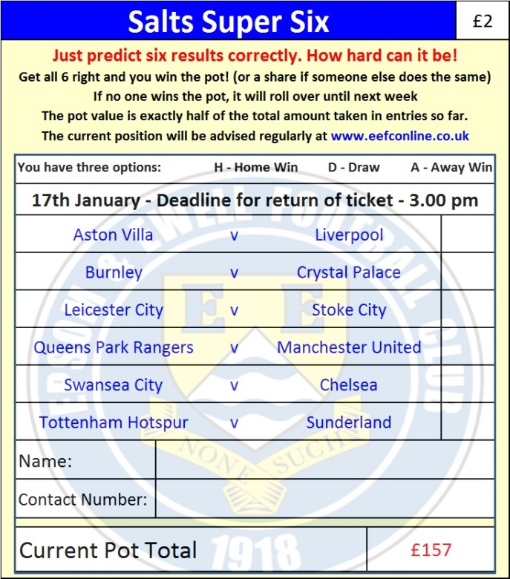
The Salts Super Six Predictor is live again and the next set of matches are on Saturday 17th January. Tickets are on sale at tonight’s game.

The competition is easy to play and you don’t even have to be at the match! To win, you simply need to predict the results of six matches correctly from the three options, fill in the form and make sure it is back with one of our distributors before the deadline on the ticket. The latest fixtures are shown here. Last week we had two entrants with five winning results so it won’t be long…

If you are a club regular, you just need to place your name on the sheet, although if you aren’t, then we’ll need a contact number from you too. We will announce any winners on the website within three working days, so don’t worry, we won’t miss you!

The prize pot is currently £157 but will continue to go up, if unclaimed, by the cost of 50% of all the sold tickets. In other words, if we sell 100 tickets at £2 before the deadline, and the pot isn’t won, then the next prize would be £257! You’ll always know the size of the pot before you enter.

Please note that if there is more than one winner, the prize pot would be shared between the winners. All you need to do now is have a go, as many times as you like!

Good luck!

Combined Counties League – Premier Division
Saturday, 17th January 2015 - Kick-off 3.00 p.m.
Epsom and Ewell  (Royal Blue & White hoops) | V |  | Farnham Town  (Claret and Sky Blue)
 | NUMBERS
Michael Eacott |  |  | Kallum Lunn
James Taylor |  |  | Danny Leeds
Steve Rowe |  |  | Max Meaton
Anthony Panayi |  |  | Darren Wilson
George Murphy |  |  | Lee Marker
Dan Dean |  |  | John Lancashire
Matt Ferdinando |  |  | Ben Williams
Matt Farrell |  |  | Ryan Mathews
Kyle Hough |  |  | Jack Dillon
Alex McGregor |  |  | Robert Palmer
Matt Robinson |  |  | Paul Douglass
Daryl Cooper-Smith |  |  | Adam Wareham
Alex McKay |  |  | Drew Mathews
Sam Robinson |  |  | James Neville
Matt Tanton |  |  | Elliot Cardona
Savva ‘Agi’ Panayiotou |  |  | Josh Dixon
Sam Currie |  |  | Matt Glass
Ali Dewar |  |  | Mark Corbett
Robbie Burns |  |  | Dan Framp
Ben Hayward
Glyn Mandeville | MANAGER |  | Paul Tanner
Matt Smith | ASSISTANT
Steve Eacott / Alex McKay | COACHES |  | Sean Birchenall / Dean Nelson
Ken Jones | PHYSIO
REFEREE: M.Dlamini (Aldershot)
ASSISTANTS: M.Stevens (Morden), R.Van Niekerk (Sutton)
Today’s Match and Match Ball are sponsored
in memory of Chris Henry

OUR NEXT VISITORS TO HIGH ROAD
Westfield
Saturday 31st January 2015 - Kick-off 3.00 p.m.
Combined Counties League – Premier Division

